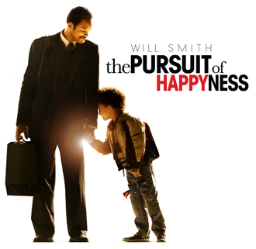

Name_______________________
Entrepreneurship 2203

1) Define the term ‘networking’. Discuss how Chris Gardner used networking to advance his career.
________________________________________________________________________________________________________________________________________________________________________________________________________________________________________________________________________________________________________________________________________________________________________________________________________________________________________________________________________________________________________________________________________________________________________________________________________________________________________________________________________________________________________________________________________________________________________________________________________________________
2) For each of the three personal characteristic concepts below, give an example for Chris Gardner and for yourself. Explain.
VALUE
Chris___________________________________________________________________________________________________________________________________________________________________________________________________________________________________________________________________________________________
You____________________________________________________________________________________________________________________________________________________________________________________________________________________________________________________________________________________________________________________________________________________________________

ATTITUDE
Chris___________________________________________________________________________________________________________________________________________________________________________________________________________________________________________________________________________________________
You____________________________________________________________________________________________________________________________________________________________________________________________________________________________________________________________________________________________________________________________________________________________________
SKILL/APTITUDE
Chris___________________________________________________________________________________________________________________________________________________________________________________________________________________________________________________________________________________________
You____________________________________________________________________________________________________________________________________________________________________________________________________________________________________________________________________________________________________________________________________________________________________

The Changeling Eagle
Native American folklore is rich with thought-provoking stories and legends. This is one of them.
A young brave, alone in the forest, found an eagle's egg and, thinking it was the egg of a prairie chicken, placed it in a prairie chicken's nest. The changeling eagle grew up thinking he was a prairie chicken. He clucked like a chicken, walked like a chicken, lived like a chicken. Like the other chickens, his “flight” was nothing more than the flailing of wings, taking him only a few feet at a time.
One bright spring day, the changeling eagle saw an awesome sight. It was a huge, graceful bird soaring high in the sky-gliding almost effortlessly. The changeling was amazed. “What was that?” he asked his prairie chicken mother. “Oh,” she said, “that is an eagle-the greatest, fastest, and most magnificent of all birds.” The changeling thought how wonderful it would be to be an eagle. What a joy it must be to look so beautiful, to fly so gracefully, to be so magnificent. But, because he knew he could never be like the eagle, the changeling quickly forgot about what he had seen and went on living as he always had.
Days, seasons, and years passed. The changeling never knew he was an eagle, and he died a prairie chicken.
3) Chris Gardner could easily have lived his life like this changeling/prairie chicken, but he did not. Discuss this statement, giving consideration to self concept and other personal characteristics.
________________________________________________________________________________________________________________________________________________________________________________________________________________________________________________________________________________________________________________________________________________________________________________________________________________________________________________________________________________________________________________________________________________________________________________________________________________________________________________________________________________________________________________________________________________________________________________________________________________________________________________________________________________________________________________________________________________________________________________________________________________________________________________________________________________________________________________________________________________________________________________________________________________________________________________________________________________________________________________________________________________________________________________________________________________________________________________________________________________________________

Chris Gardner: Hey! Don't ever let somebody tell you that you can't do something. Not even me. All right?
Christopher: All right.
Chris Gardner: You got a dream... you gotta protect it! People can't do somethin' themselves, they wanna tell you you can't do it. If you want somethin', go get it… Period.

