Motivation and Work Modules 36-39
Motivational Concepts
  - Instincts and Evolutionary Psychology
  - Drives and Incentives
  - Optimum Arousal
  - A Hierarchy of Motives
Motivation Module 36
Motivation is a need or desire that energizes behavior and directs it towards a goal.
Aron Ralston was motivated to cut his arm in order to free himself from a rock that pinned him down.
Perspectives on Motivation
Four perspectives used to explain motivation include the following:
1. Instinct Theory (replaced by the evolutionary perspective)
2. Drive-Reduction Theory
3. Arousal Theory
4. Hierarchy of Motives
Instincts & Evolutionary Psychology
Instincts are complex behaviors that have fixed patterns throughout different species and are not learned (Tinbergen, 1951).
Drives and Incentives
When the instinct theory of motivation failed, it was replaced by the drive-reduction theory. A physiological need creates an aroused tension state (a drive) that motivates an organism to satisfy the need.
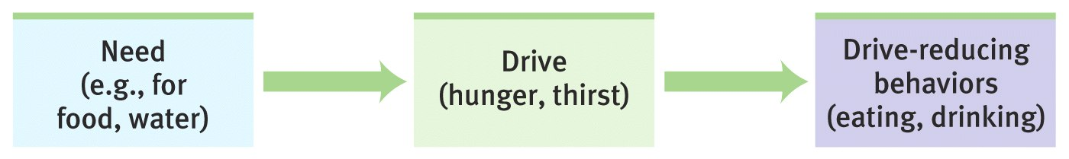
Incentive
Where our needs push, incentives (positive or negative stimuli) pull us in reducing our drives.
Ex.: A food-deprived person who smells baking bread(incentive) feels a strong hunger drive.

Optimum Arousal
Human motivation aims to seek optimum levels of arousal, not to eliminate it. Young monkeys and children are known to explore the environment in the absence of a need-based drive.
A Hierarchy of Motives
Abraham Maslow (1970) suggested that certain needs have priority over others. Physiological needs like breathing, thirst, and hunger come before psychological needs such as achievement, self-esteem, and the need for recognition.
Hierarchy of Needs
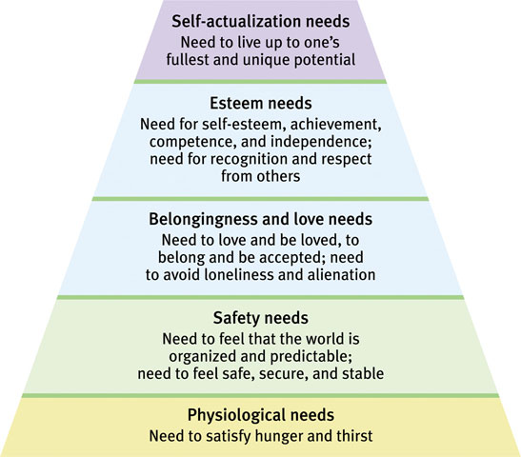
Hunger (Module 37)
  - The Physiology of Hunger
  - The Psychology of Hunger
  - Obesity and Weight Control
Hunger
When do we eat? When we are hungry.
When are we hungry? When there is no food in our stomach.
How do we know when our stomach is empty? Our stomach growls. These are also called hunger pangs.
The Physiology of Hunger
Stomach contractions (pangs) send signals to the brain making us aware of our hunger.
Stomachs Removed
Tsang (1938) removed rat stomachs, connected the esophagus to the small intestines, and the rats still felt hungry (and ate food).
Body Chemistry & the Brain
Levels of glucose in the blood are monitored by receptors (neurons) in the stomach, liver, and intestines. They send signals to the hypothalamus in the brain.
Hypothalamic Centers
The lateral hypothalamus (LH) brings on hunger (stimulation). Destroy the LH, and the animal has no interest in eating. The reduction of blood glucose stimulates orexin in the LH, which leads rats to eat ravenously.
The ventromedial hypothalamus (VMH) depresses hunger (stimulation). Destroy the VMH, and the animal eats excessively.
Hypothalamus & Hormones
The hypothalamus monitors a number of hormones that are related to hunger.
Hormone | Tissue | Response
Orexin increase | Hypothalamus | Increases hunger
Ghrelin increase | Stomach | Increases hunger
Insulin increase | Pancreas | Increases hunger
Leptin increase | Fat cells | Decreases hunger
PPY increase | Digestive tract | Decreases hunger
Set Point
Manipulating the lateral and the ventromedial hypothalamus alters the body’s “weight thermostat.” Heredity influences set point and body type.
If weight is lost, food intake increases and energy expenditure decreases. If weight is gained, the opposite takes place.
The Psychology of Hunger
Memory plays an important role in hunger. Due to difficulties with retention, amnesia patients eat frequently if given food (Rozin et al., 1998).
Taste Preference: Biology or Culture?
Body chemistry and environmental factors influence not only when we feel hunger but what we feel hungry for!
Hot Cultures like Hot Spices
Countries with hot climates use more bacteria-inhibiting spices in meat dishes.
Eating Disorders
Anorexia Nervosa: A condition in which a normal-weight person (usually an adolescent woman) continuously loses weight but still feels overweight.
Bulimia Nervosa: A disorder characterized by episodes of overeating, usually high-calorie foods, followed by vomiting, using laxatives, fasting, or excessive exercise.
Reasons for Eating Disorders
- Sexual Abuse: Childhood sexual abuse does not cause eating disorders.
- Family: Younger generations develop eating disorders when raised in families in which weight is an excessive concern.
- Genetics: Twin studies show that eating disorders are more likely to occur in identical twins rather than fraternal twins.
Obesity and Weight Control
Fat is an ideal form of stored energy and is readily available. In times of famine, an overweight body was a sign of affluence.
Obesity
A disorder characterized by being excessively overweight. Obesity increases the risk for health issues like cardiovascular diseases, diabetes, hypertension, arthritis, and back problems.
Body Mass Index (BMI)
Obesity in children increases their risk of diabetes, high blood pressure, heart disease, gallstones, arthritis, and certain types of cancer, thus shortening their life-expectancy.
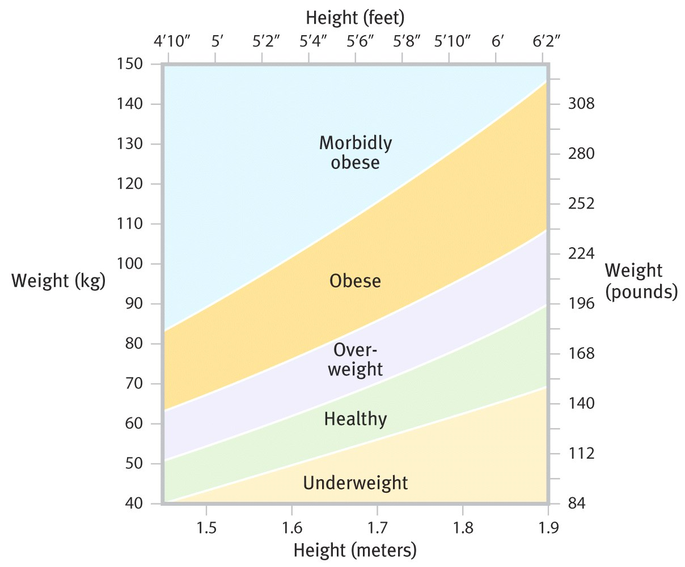
Obesity and Mortality
The death rate is high among very overweight men.
Social Effects of Obesity
When women applicants were made to look overweight, subjects were less willing to hire them.
Physiology of Obesity
Fat Cells: There are 30-40 billion fat cells in the body. These cells can increase in size (2-3 times their normal size) and number (75 billion) in an obese individual (Sjöstrum, 1980).
Set Point and Metabolism
When reduced from 3,500 calories to 450 calories, weight loss was a minimal 6% and the metabolic rate a mere 15%.
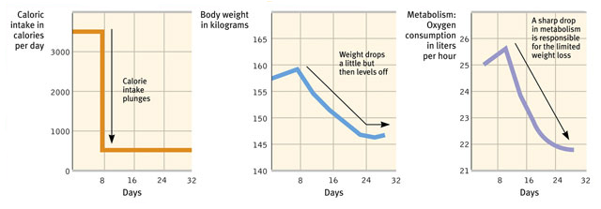
The obese defend their weight by conserving energy.
The Genetic Factor
Identical twin studies reveal that body weight has a genetic basis.
The obese mouse on the left has a defective gene for the hormone leptin. The mouse on the right sheds 40% of its weight when injected with leptin.
Activity
Lack of exercise is a major contributor to obesity. Just watching TV for two hours resulted in a 23% increase of weight when other factors were controlled (Hu & others, 2003).
Food Consumption
Over the past 40 years, average weight gain has increased. Health professionals are pleading with US citizens to limit their food intake.
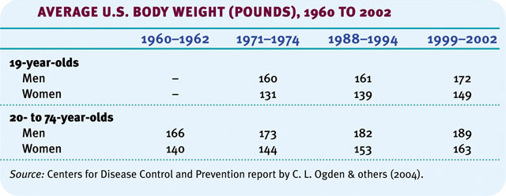
Losing Weight
In the US, two-thirds of the women and half of the men say they want to lose weight. The majority of them lose money on diet programs.
Plan to Lose Weight
When you are motivated to lose weight, begin a weight-loss program, minimize your exposure to tempting foods, exercise, and forgive yourself for lapses.
Summary
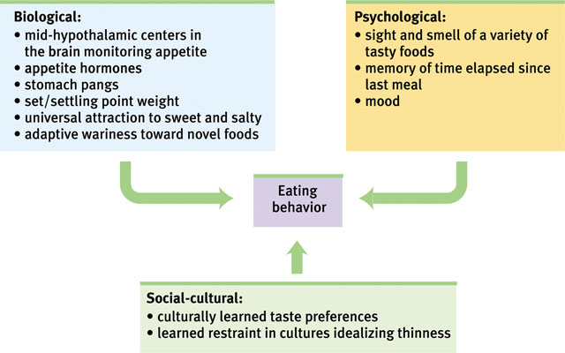
Sexual Motivation (Module 38)
  - The Physiology of Sex
  - The Psychology of Sex
  - Adolescent Sexuality
  - Sexual Orientation
  - Sex and Human Values
The Need to Belong
Sexual Motivation
Sexual motivation is nature’s clever way of making people procreate, enabling our species to survive.
The Physiology of Sex
Masters and Johnson (1966) describe the human sexual response cycle as consisting of four phases:
Phase | Physiological Response
Excitement | Genitals become engorged with blood. Vagina expands secretes lubricant. Penis enlarges.
Plateau | Excitement peaks such as breathing, pulse and blood pressure.
Orgasm | Contractions all over the body. Increase in breathing, pulse & blood pressure. Sexual release.
Resolution | Engorged genital release blood. Male goes through refractory phase. Women resolve slower.

Sexual Problems
Men generally suffer from two kinds of sexual problems: premature ejaculation and erectile disorder. Women may suffer from orgasmic disorders.
These problems are not due to personality disorders and can be treated through behavior therapy and drugs such as Viagra.
Hormones and Sexual Behavior
Sex hormones effect the development of sexual characteristics and (especially in animals) activate sexual behavior.
Male | Testes | Testosterone  (Small amounts of estrogen)
Female | Ovaries  Adrenals | Estrogen  (Small amounts of testosterone)

Estrogen
Female animals “in heat” express peak levels of estrogen. Female receptivity may be heightened with estrogen injections.
Sex hormones may have milder affects on humans than on animals. Women are more likely to have sex when close to ovulation (increased testosterone), and men show increased testosterone levels when socializing with women.
Testosterone
Levels of testosterone remain relatively constant in males, so it is difficult to manipulate and activate sexual behavior. Castration, which reduces testosterone levels, lowers sexual interest.
The Psychology of Sex
Hunger responds to a need. If we do not eat, we die. In that sense, sex is not a need because if we do not have sex, we do not die.
External Stimuli
It is common knowledge that men become sexually aroused when browsing through erotic material. However, women experience similar heightened arousal under controlled conditions.
Imagined Stimuli
Our imagination in our brain can influence sexual arousal and desire. People with spinal cord injuries and no genital sensation can still feel sexual desire.
Adolescent Sexuality
When individuals reach adolescence, their sexual behavior develops. However, there are cultural differences.
Sexual promiscuity in modern Western culture is much greater than in Arab countries and other Asian countries.
Contraception
- Ignorance: Canadian teen girls do not have the right ideas about birth control methods.
- Guilt Related to Sexual Activity: Guilt reduces sexual activity, but it also reduces the use of contraceptives.
- Minimal Communication: Many teenagers feel uncomfortable discussing contraceptives.
- Alcohol Use: Those who use alcohol prior to sex are less likely to use contraceptives.
- Mass Media: The media’s portrayal of unsafe extramarital sex decreases the use of contraceptives.
Sexually Transmitted Infections
Factors that reduce sexual activity in teens.
- High Intelligence: Teens with higher intelligence are likely to delay sex.
- Religiosity: Religious teens and adults often reserve sex for a marital commitment.
- Father Presence: A father’s absence from home can contribute to higher teen sexual activity.
- Learning Programs: Teens who volunteer and tutor in programs dedicated to reducing teen pregnancy are less likely to engage in unsafe sex.
Sexual Orientation
Sexual orientation refers to a person’s preference for emotional and sexual relationships with individuals of the same sex, the other sex, and/or either sex.
Sexual Orientation Statistics
In Europe and America, based on many national surveys, homosexuality in men is 3-4% and in women is 1-2%.
As members of a minority, homosexuals often struggle with their sexual orientation.
Origins of Sexual Orientation
Homosexuality is more likely based on biological factors like differing brain centers, genetics, and parental hormone exposure rather than environmental factors.
Animal Homosexuality
A number of animal species are devoted to same-sex partners, suggesting that homosexuality exists in the animal world.
Genes & Sexual Orientation
A number of reasons suggest that homosexuality may be due to genetic factors.
- Family: Homosexuality seems to run in families.
- Twin studies: Homosexuality is more common in identical twins than fraternal twins. However, there are mixed results.
- Fruit flies: Genetic engineers can genetically manipulate females to act like males during courtship and males to act like females.
Sexual Orientation: Biology
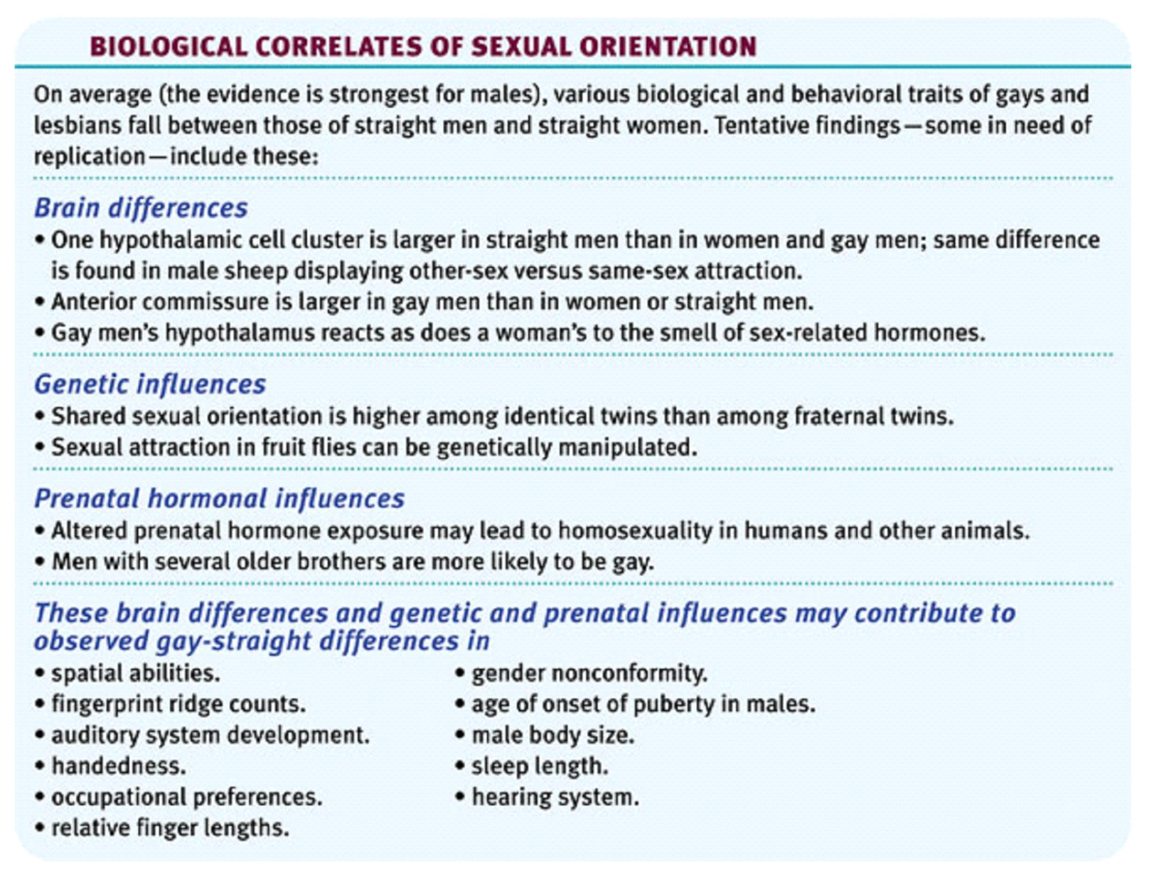
Changing Attitudes
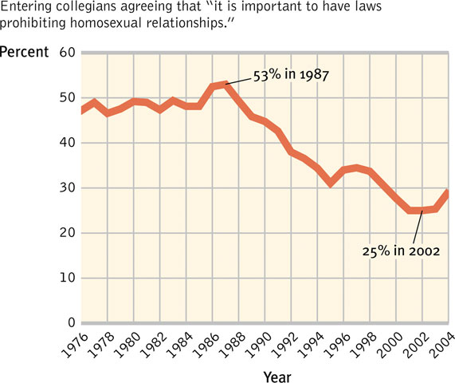
Sex and Human Values
“Promiscuous recreational sex poses certain psychological, social, health, and moral problems that must be faced realistically” (Baumrind, 1982).
The Need to Belong
“[Man] is a social animal,” (Aristotle). Separation from others increases our need to belong.
Aiding Survival
Social bonds boosted our ancestors’ survival rates. These bonds led to the following:
- Protecting against predators, especially for the young.
- Procuring food.
- Reproducing the next offspring.
Belongingness
- Wanting to Belong: The need to belong colors our thinking and emotions.
- Social Acceptance: A sense of belonging with others increases our self-esteem. Social segregation decreases it.
- Maintaining Relationships: We resist breaking social bonds, even bad ones.
- Ostracism: Social exclusion leads to demoralization, depression, and at times nasty behavior.
Module 39 “Close-Up”
Motivation at Work
  - Personnel Psychology
  - Organizational Psychology: Motivating Achievement
Achievement Motivation
Achievement motivation is defined as a desire for significant accomplishment.
Skinner devised a daily discipline schedule that led him to become the 20th century’s most influential psychologist.
People with a high need to achieve tend to:
- choose tasks that allow for success, yet
- still require skill and effort, and
- keep persisting until success is achieved.
Sources of Achievement Motivation
Why does one person become more motivated to achieve than another? Parents and teachers have an influence on the roots of motivation.
Emotional roots: learning to associate achievement with positive emotions.
Cognitive roots: learning to attribute achievements to one’s own competence, thus raising expectations of oneself.
Psychology at Work
The healthy life, said Sigmund Freud, is filled by love and work.
Attitudes Towards Work
People have different attitudes toward work. Some take it as a:
- Job: Necessary way to make money.
- Career: Opportunity to advance from one position to another.
- Calling: Fulfilling a socially useful activity.
Flow & Rewards
Flow is the experience between no work and a lot of work. Flow marks immersion into one’s work.
People who “flow” in their work (artists, dancers, composers etc.) are driven less by extrinsic rewards (money, praise, promotion) and more by intrinsic rewards.
Work and Satisfaction
In industrialized countries work and satisfaction go hand-in-hand.
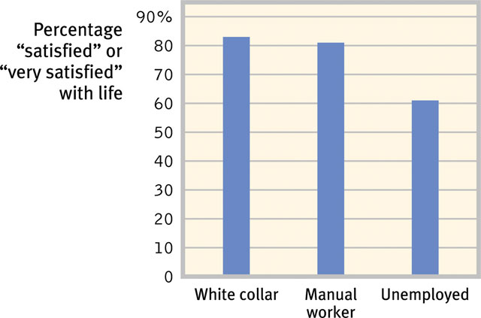
Industrial-Organizational (I/O) Psychology
Applies psychological principles to the workplace.
- Personnel Psychology: Studies the principles of selecting and evaluating workers.
- Organizational Psychology: Studies how work environments and management styles influence worker motivation, satisfaction, and productivity.
- Human Factors Psychology: Explores how machines and environments can be designed to fit our natural perception.
Personnel Psychology
Personnel psychologists assist organizations at various stages of selecting and assessing employees.
Harnessing Strengths
Identifying people’s strengths (analytical, disciplined, eager to learn etc.) and matching them to a particular area of work is the first step toward workplace effectiveness.
Do Interviews Predict Performance?
Interviewers are confident in their ability to predict long-term job performance. However, informal interviews are less informative than standardized tests.
The Interviewer Illusion
Interviewers often overrate their discernment.
- Intention vs. Habits: Intensions matter, but long- lasting habits matter even more.
- Successful Employees: Interviewers are more likely to talk about those employees that turned out successful.
- Presumptions about Candidates: Interviewers presume (wrongly) that what we see (candidate) is what we get.
- Preconceptions: An interviewer’s prior knowledge about the candidate may affect her judgment.
Structured Interview
A formal and disciplined way of gathering information from the interviewee. Structured interviews pinpoint strengths (attitudes, behaviors, knowledge, and skills). The personnel psychologist may do the following:
- Analyze the job.
- Script questions.
- Train the interviewer.
Appraising Performance
Appraising performance serves the purposes of: 1) employee retention, 2) determining rewards/pay and 3) the encouragement of better performance.
Personnel Psychologist’s Tasks
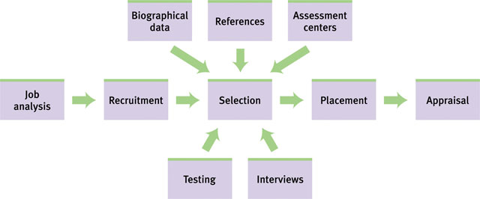
Organizational Psychology
Organizational psychologists look for ways to engage and motivate workers.
Satisfaction & Engagement
Harter et al., (2002) observed that employee engagement means that the worker:
- Knows what is expected of him.
- Has what is needed to do the work.
- Feels fulfilled at work.
- Has opportunities to do his best.
- Thinks himself to be a part of something significant.
- Has opportunities to learn and develop.
- Engaged workers are more productive
- than non-engaged workers at different stores
- of the same chain.
Managing Well
Every leader dreams of managing in ways that enhance people’s satisfaction, engagement, and productivity in his or her organization.
Harnessing Job-Relevant Strengths
Effective leaders need to select the right people, determine their employees’ talents, adjust their work roles to their talents, and develop their talents and strengths.
