**Local Weather 4**

**Outcomes: (330-6), (213-6), (213-7), (331-5)**

**Content: Page 208-209 & 270-272**

## **Weather Maps and Symbols:**

* You should all be familiar to weather maps used on TV weather broadcasts.
* A weather map gives us a ____________________________________  
  ________________________________________________________
* The map is created by gathering weather data from _____________  
  ____________________________________________________________
* Weather maps show us the weather conditions _________________  
  __________________________________________
* They give us an idea of the type of ___________________ (rain, snow, rain, fog), the ________________________, positions of high and low ________________________, weather ________________ and the position of the ____________________________.
* The information on weather maps is written down as ____________.
* In order to accurately describe the __________________________ we need to know what these symbols are and what they mean to the __________________________________________.

**Here are the basic weather symbols found on weather maps.**

### **Pressure systems:**

### _________________________ (indicated by H)



### __________________________ (indicated by L)



### A high-pressure system usually means fair (clear) weather.

### The high-pressure system is made up of _____________ ______________________________________________

### If the air cannot rise, then __________________________

* + A low-pressure system usually means ______________________  
    _____________________________________
  + A low-pressure system is made up of ________________  
    __________________________________________
  + The air begins to rise and _________________________.
  + As the air cools, it ________________________________  
    _______________________________________, rain, snow, or other forms of precipitation.

### **2. Air Temperature:**

* Air temperature changes from region to region, depending on _________________________________.
* Most weather maps use a ________________________ to indicate the temperature.

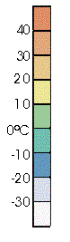

* The colour of the region of the map tells you ___________  
  ______________________________________ of that area.
* Temperature is measured in ____________________________

### 

### **3. Weather conditions:**

|  |  |
| --- | --- |
| ________________________ |  |
| ________________________ |  |
| _______________________ |  |
| ________________________ |  |

### **4. Fronts:**

|  |  |
| --- | --- |
| ___________________________ |  |
| ___________________________ |  |
| ____________________________ |  |
| _____________________________ |  |

* As you learned in the last lesson, ___________________________  
  ____________________________________________________
* No matter what type of front is moving through it _______________  
  ___________________________________________________
* By considering the type of front we can tell how much rain we will get, how long it will last, and the _____________________________  
  ________________________________________________________

### **5. Jet Stream:**



* A narrow region of _________________________________________
* Jet streams are caused by the collisions of the ________________  
  ______________________________________________________
* When these air masses collide they create a _____________  
  _____________________________________(greater than 400 km/h).
* The air North of the jet stream is from the polar air masses, so the __________________________________________________________.
* The air South of the jet stream is from the tropical air masses which is __________________________________________.
* As these huge air masses push against each other the ___________  
  ________________________________________
* The high and low pressure systems causing the local weather to get _______________________________________________________.
* Weather forecasters use the position of the jet stream to _________  
  __________________________________________________________

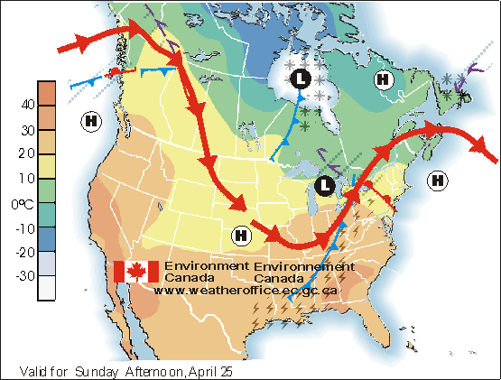

Based on this weather map, what weather conditions are being experienced by:

|  |  |
| --- | --- |
| 1. Newfoundland |  |
| 2. Labrador |  |
| 3. Coastal British Columbia |  |
| 4. Florida |  |

|  |  |
| --- | --- |
| 5. What types of fronts are shown on this map? |  |

**Homework: Page 208 a-j**

**SRL: 4.4: Case study: Three days of Canadian weather: p 322 - 325.**