**Local Weather 4**

**Outcomes: (330-6), (213-6), (213-7), (331-5)**

**Content: Page 208-209 & 270-272**

## **Weather Maps and Symbols:**

* You should all be familiar to weather maps used on TV weather broadcasts.
* A weather map gives us a picture of the current weather conditions.
* The map is created by gathering weather data from different weather stations across Canada.
* Weather maps show us the weather conditions close to the ground.
* They give us an idea of the type of precipitation (rain, snow, rain, fog), the air temperature, positions of high and low pressures, weather fronts, and the position of the jet stream.
* The information on weather maps is written down as symbols.
* In order to accurately describe the weather conditions we need to know what these symbols are and what they mean to the local weather.

**Here are the basic weather symbols found on weather maps.**

### **Pressure systems:**

### High pressure region (indicated by H)



### Low pressure region (indicated by L)



### A high-pressure system usually means fair (clear) weather.

### The high-pressure system is made up of heavy, cool air that cannot rise.

### If the air cannot rise, then clouds cannot form

* + A low-pressure system usually means unstable stormy weather.
  + A low-pressure system is made up of warm, light, moist air.
  + The air begins to rise and as it rises it cools.
  + As the air cools, it releases its moisture to form clouds, rain, snow, or other forms of precipitation.

### **2. Air Temperature:**

* Air temperature changes from region to region, depending on the air mass.
* Most weather maps use a colour scale to indicate the temperature.

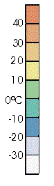

* The colour of the region of the map tells you the temperature of that area.
* Temperature is measured in degrees Celsius  (oC)

### 

### **3. Weather conditions:**

|  |  |
| --- | --- |
| Rain |  |
| Freezing rain |  |
| Snow |  |
| Thunderstorm |  |

### **4. Fronts:**

|  |  |
| --- | --- |
| Warm front |  |
| Cold front |  |
| Stationary Front |  |
| Occluded Front |  |

* As you learned in the last lesson, fronts are caused by the collision of air masses.
* No matter what type of front is moving through it usually means rain or snow.
* By considering the type of front we can tell how much rain we will get, how long it will last, and the type of weather conditions that will follow.

### **5. Jet Stream:**



* A narrow region of very fast moving air.
* Jet streams are caused by the collisions of the major air masses at high altitudes.
* When these air masses collide they create a narrow region of very fast moving air (greater than 400 km/h).
* The air North of the jet stream is from the polar air masses, so the air above the jet stream is generally cooler.
* The air South of the jet stream is from the tropical air masses which is generally warmer.
* As these huge air masses push against each other the jet stream changes shape.
* The high and low pressure systems causing the local weather to get pushed around and follow the jet stream.
* Weather forecasters use the position of the jet stream to predict the path of high and low pressure systems.

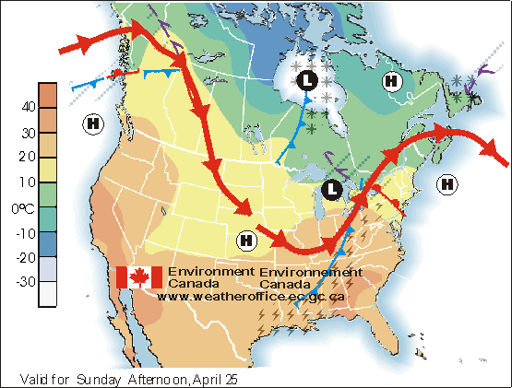

Based on this weather map, what weather conditions are being experienced by:

|  |  |
| --- | --- |
| 1. Newfoundland |  |
| 2. Labrador |  |
| 3. Coastal British Columbia |  |
| 4. Florida |  |

|  |  |
| --- | --- |
| 5. What types of fronts are shown on this map? |  |

**Homework: Page 208 a-j**

**SRL: 4.4: Case study: Three days of Canadian weather: p 322 - 325.**