Local Weather 3
Outcome: (330-6)

Content: Page 206-207

North American Weather Systems:
- We have all seen the local TV weather person tracking a storm and _____________________________________________________________________________________________________
- They can do this by looking at the weather that is being experienced by areas that are getting the storm now and then ______________________________________________
__________________________________________________
- This is a very common technique that ___________________________________________________
Weather System:
- A set of __________________________________________
_______________________________________________
- Changes in weather are caused __________________
____________________________________________
- This is what a _____________________________________

- Weather systems are _________________________
________
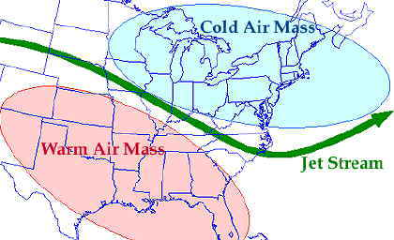

  - An air mass can range in size from _____________________________________________
  - These large air masses have _____________________________________________
  - The temperature and humidity of the air mass depends on __________________________________
____________________________________________
  - Air masses that form over water tend to pick up and carry much more _____________________________
______________________________________________
  - Air masses that form up in the cold North tend to be cool while ____________________________________
______________________________________________
In general there are four types of air masses that affect the weather in North America:
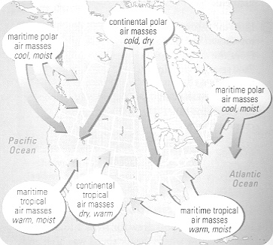
- ________________________________________
- _________________________________________
- ________________________________________
- _______________________________________
  - Quite simply, maritime means it is ____________________________________________
  - That is, forming over ______________________
_____________________________
  - As the maritime air mass grows it will suck up _________________________________________.
  - This air will be _________________________
  - Continental means it is ____________________________
  - Since there is very little moisture to pick up over the land, the _______________________________
________________________________________
  - Polar means it is formed _________________________
_____________________________________________
  - Most of the North Pole is covered in ice and snow, which means the _____________________
___________________________________________
  - Tropical means the air mass is formed in the __________________________________________________
  - As the air mass grows in the tropical regions it __________________________________________
________________________________________
 | Polar (cold) | Tropical (Warm)
Maritime (wet) | Wet and cold | wet and warm
Continental (Dry) | Dry and cold | Dry and warm
- Polar Maritime air masses are __________________ and usually _________________________________________ and ___________________________________________ in the winter.
- Tropical maritime air masses are _____________________ and usually bring ________________________________ and ___________________________________________ in the winter.

What happens if these air masses collide?
- When two air masses meet, the ______________________________________________________________________________________________
- The weather conditions at the ________________________
___________________________________________________
There are four types off fronts:
- ___________________________________
- _____________________________________
- _____________________________________
- ______________________________________

The type of front formed depends on _____________________________________________________

Cold Front:

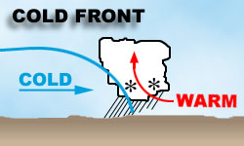
- Caused when a _________________________________
______________________________________________
- The warm air is _________________________________
- As the warm air rises it begins to cool and is forced to _____________________________________.
- This moistures forms clouds at first but then develops into __________________________________________________
- As the front moves through the conditions begin to clear.
- The air that follows behind the cold front is ________________________________________

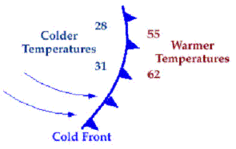

Warm Front:

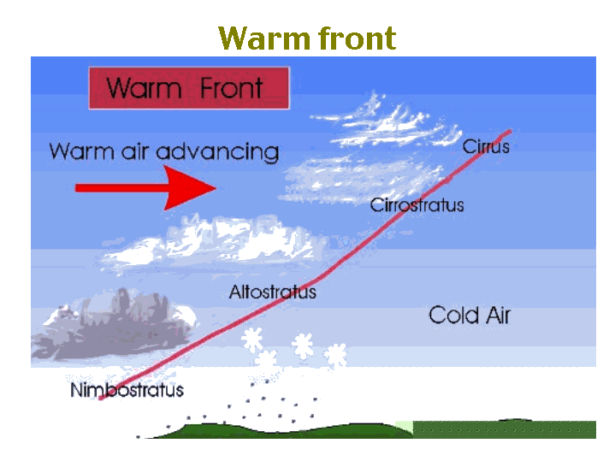
- Caused by _____________________________________ a stationary (stopped) cold air mass.
- As the ___________________________________________ (or flurries) develop.
- Conditions are ___________________________________
- The air that follows behind the warm front is ________________________________________________
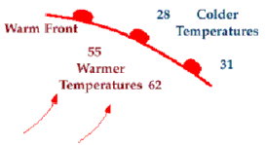

Occluded Front: 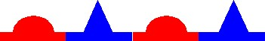

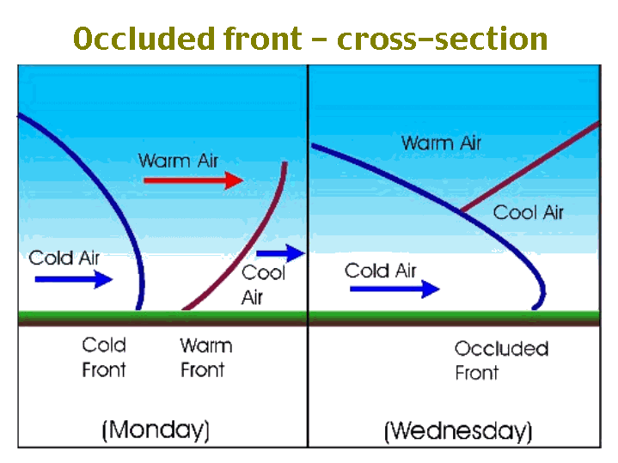
- Cold air masses move _________________________
___________________________________________
- An occluded front is formed when a _______________
____________________________________________________________________________________________________
- The cold air mass slowly pushes the warm air up _____________________________________________.
- Storms caused by an occluded front are ____________________________________________

Stationary Front:

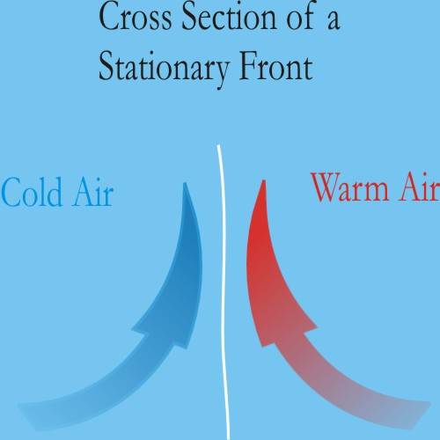
- Sometimes when the ______________________________
_________________________________________________
- The front slowly moves through over a ___________________________________________________
- Stationary fronts usually bring _______________________
_____________________________________ and the conditions stay quite calm.
- It is common to
_____________________________________________________________________________________________________
________________________________________________
Homework: Page 207: # 1 - 5.
SRL: 4.3 : North American Weather Systems (Handout)

