Local Weather 3
Outcome: (330-6)

Content: Page 206-207

North American Weather Systems:
- We have all seen the local TV weather person tracking a storm and predicting the weather a day or two in advance.
- They can do this by looking at the weather that is being experienced by areas that are getting the storm now and then estimating how long it will take that storm to get to us.
- This is a very common technique that is used to forecast the weather.
Weather System:
- A set of weather conditions that move through a region for a period of days
- Changes in weather are caused by movements in these systems
- This is what a weather forecaster normally tracks
- Weather systems are made up of large air masses.
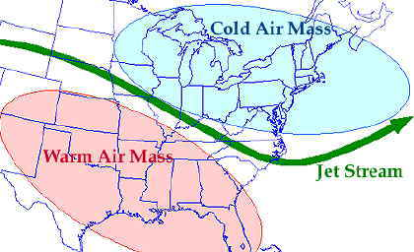

  - An air mass can range in size from 100 km to 1000 km across.
  - These large air masses have the same temperature and humidity.
  - The temperature and humidity of the air mass depends on where the air mass begins to grow.
  - Air masses that form over water tend to pick up and carry much more moisture than air masses formed over land.
  - Air masses that form up in the cold North tend to be cool while air masses that form in the warm tropical regions tend to be warm.
In general there are four types of air masses that affect the weather in North America:
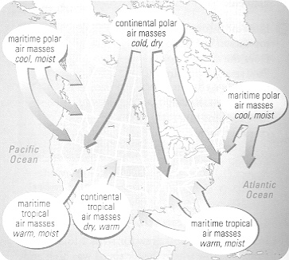
- Maritime polar
- Continental polar
- Maritime tropical
- Continental tropical
  - Quite simply, maritime means it is formed over water.
  - That is, forming over the Atlantic or Pacific Ocean.
  - As the maritime air mass grows it will suck up moisture from the ocean like a sponge.
  - This air will be very wet.
  - Continental means it is formed over land
  - Since there is very little moisture to pick up over the land, the continental air mass will be dry.
  - Polar means it is formed in the cold regions of the North Pole.
  - Most of the North Pole is covered in ice and snow, which means the air over the ice, and snow will be cold also.
  - Tropical means the air mass is formed in the warm tropical regions around the equator.
  - As the air mass grows in the tropical regions it gains a great deal of energy from the hot sun.
 | Polar (cold) | Tropical (Warm)
Maritime (wet) | Wet and cold | wet and warm
Continental (Dry) | Dry and cold | Dry and warm
- Polar Maritime air masses are cold and wet and usually bring fog and cool temperatures in the summer and heavy snow and very cold temperatures in the winter.
- Tropical maritime air masses are warm and wet and usually bring warm "muggy" rain in the summer and slushy snow and mild temperatures in the winter.

What happens if these air masses collide?
- When two air masses meet, the boundary that forms between them is called a front.
- The weather conditions at the front are usually very stormy and unsettled. Fronts mean rain!
There are four types off fronts:
- Cold front
- Warm front
- Occluded front
- Stationary front

The type of front formed depends on how they come together.

Cold Front:

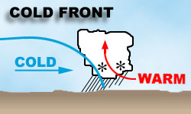
- Caused when a cold air mass pushes underneath a warm air mass.
- The warm air is forced up.
- As the warm air rises it begins to cool and is forced to lose its moisture.
- This moistures forms clouds at first but then develops into heavy rain (or snow) and very stormy weather.
- As the front moves through the conditions begin to clear.
- The air that follows behind the cold front is cool and dry.
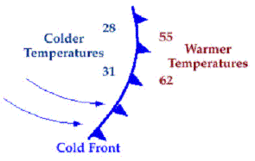

Warm Front:

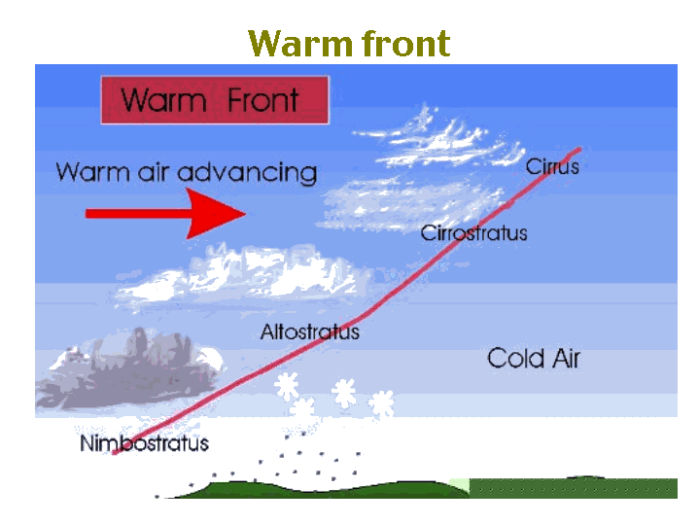
- Caused by a warm air mass moving slowly up a stationary (stopped) cold air mass.
- As the warm air slowly rises and cool showers (or flurries) develop.
- Conditions are somewhat calm.
- The air that follows behind the warm front is warm and humid (damp).
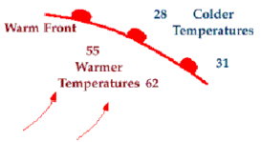

Occluded Front: 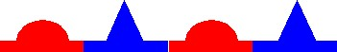

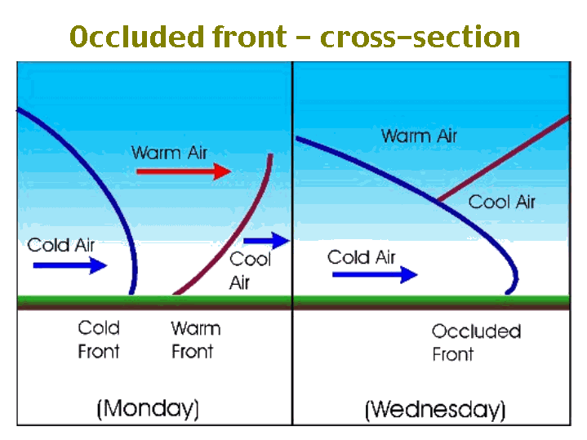
- Cold air masses move faster than warm air masses.
- An occluded front is formed when a cold air mass catches up with a slower moving warm air mass.
- The cold air mass slowly pushes the warm air up creating gentle precipitation.
- Storms caused by an occluded front are generally gentle.

Stationary Front:

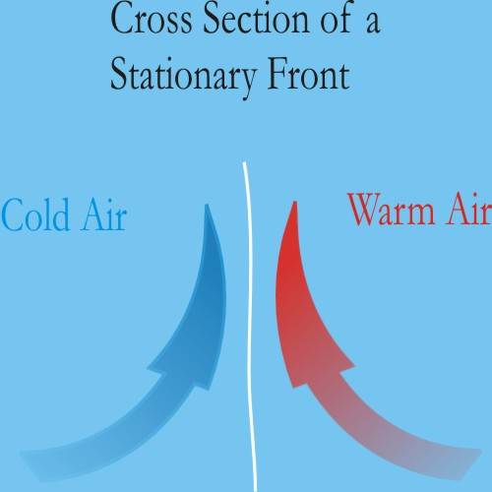
- Sometimes when the two slow moving air masses collide they stall (stop).
- The front slowly moves through over a long period of time.
- Stationary fronts usually bring rain / or snow for long periods of time and the conditions stay quite calm.
- It is common to have rain, drizzle and fog lasting for days!
Homework: Page 207: # 1 - 5.
SRL: 4.3 : North American Weather Systems (Handout)

