Global Weather 3
Outcome: (115-2), (331-1)

Content: Page 228-229

Clouds
Have you ever wondered how clouds are formed?
- Recall from other lessons that ___________________
__________________________________________.
- As the air rises ________________________________.
- This cooled air _________________________________
____________________________________.
- The water vapour begins to ______________________
____________________________________________.
- There are so many water droplets that they __________
_____________________________________________.
- Depending on the temperature clouds may be made up of _____________________________________________.

Three main types of clouds:

1. Convective
- Formed when a land mass is heated and the _________________________________________
_______________________________________.
- We see these types of clouds where ___________
________________________________________.

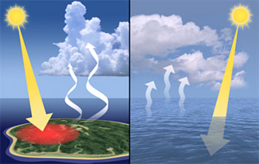

2. Frontal
- Form at the frontal zone where _______________
_______________________________________.
- The warmer air mass is forced to _____________
________________________________________.
- As the warmer air mass is forced to rise it ______
_______________________________________
_______________________________________.

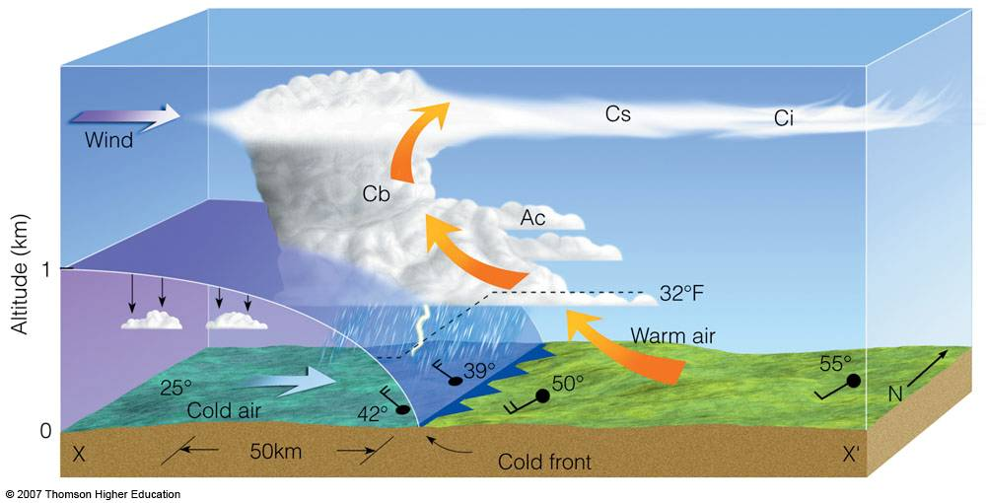

3. Orographic
- Formed because of ___________________.
- Formed when air is forced to ________________
_____________________________________.
- As the wind blows into the _________________
____________________________________.
- As the air rises it _________________________
______________________________________.

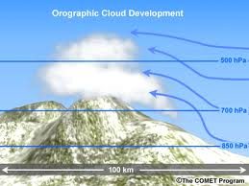

Fog:
- Cloud type that ______________________________.
- Fog forms when _____________________________
_________________________________
- The cool surface causes the warm air to ___________
___________________________________________.
- In Newfoundland warm air from the south follows the ________________________________.
  - This warm moist air then pushes over the ____________________________________.
  - These ___________________________ off the coast of Newfoundland at the Grand Banks.
  - Not surprisingly, the Grand Banks are _________
____________________________________!

Cloud shapes tell us about atmospheric conditions:

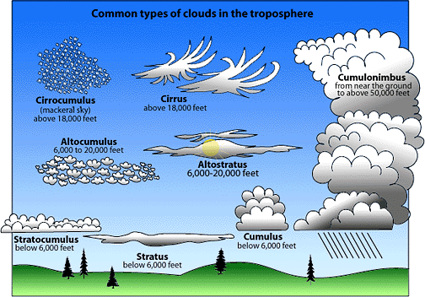

1. Cumulus Clouds:
- Heaped" or "lumpy" clouds result when ________
________________________________________.
- This shows us that the air mass is _____________
______________________________________.
- Cumulus clouds are a clue that the ____________
_________________________________________
________________________________.

2. Stratus Clouds:
- Wide __________________________________.
- These clouds give a clue that the air ___________
________________ (across) rather than vertical (up and down).
- We see this when the ______________________
_____________________________.
- This type of cloud is a _____________________
_________________________.
Cloud cover Maintains balance on earth:
- Clouds play two main roles
- The first is that they ___________________________.
  - On cloudy nights the _______________________
________________________________________.
  - When the night sky is clear __________________
________________________________________.
- The second role of clouds is to ____________________
_________________________________________.
  - The formation of white cloud cover, ____________
______________________________________.
When is there a greater risk of frost, on a cloudy night or a clear night?
- ______________________________________________
______________________________________________
______________________________________________

Deserts regions are so dry that clouds do not form during the day or the night. What do you think the temperature conditions would be like?
- ______________________________________________
___________________________________________________________________________________________
- ______________________________________________
______________________________________________
______________________________________________

Homework: Page 229: # 1

