Global Weather 3
Outcome: (115-2), (331-1)

Content: Page 228-229

Clouds
Have you ever wondered how clouds are formed?
- Recall from other lessons that when air is warmed it begins to rise.
- As the air rises it begins to cool and expand.
- This cooled air can no longer hold all its moisture.
- The water vapour begins to condense on dust particles as very tiny water droplets.
- There are so many water droplets that they appear white and block out the sky above.
- Depending on the temperature clouds may be made up of tiny water droplets and or tiny ice crystals.

Three main types of clouds:

1. Convective
- Formed when a land mass is heated and the warmed air begins to rise, expand, cool and water condenses.
- We see these types of clouds where thermals and sea breezes are formed.
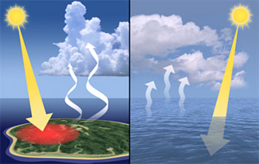

2. Frontal
- Form at the frontal zone where two large air masses meet.
- The warmer air mass is forced to rise up over the cooler air mass.
- As the warmer air mass is forced to rise it expands and cools resulting in the formation of condensation.
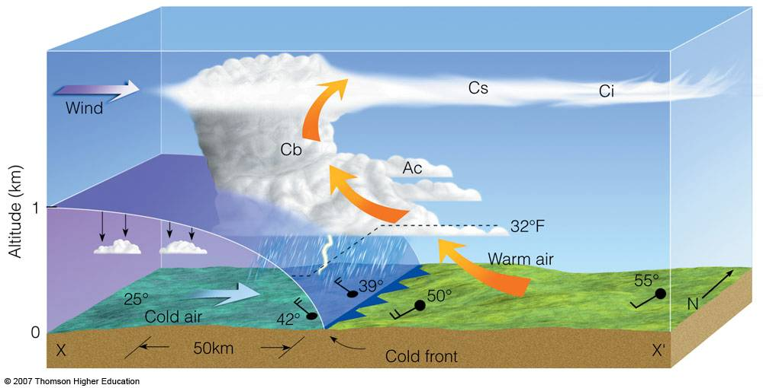

3. Orographic
- Formed because of geography.
- Formed when air is forced to rise up a large hill or mountain.
- As the wind blows into the side of the mountain it rises up.
- As the air rises it expands and cools causing water vapour to condense as clouds.

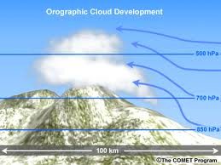

Fog:
- Cloud type that forms near the ground.
- Fog forms when warm moist air moves over a colder surface
- The cool surface causes the warm air to cool and release its moisture as very fine water droplets.
- In Newfoundland warm air from the south follows the Gulf Stream.
  - This warm moist air then pushes over the cold Labrador Current.
  - These two ocean currents collide off the coast of Newfoundland at the Grand Banks.
  - Not surprisingly, the Grand Banks are known as one of the foggiest places in the world!

Cloud shapes tell us about atmospheric conditions:

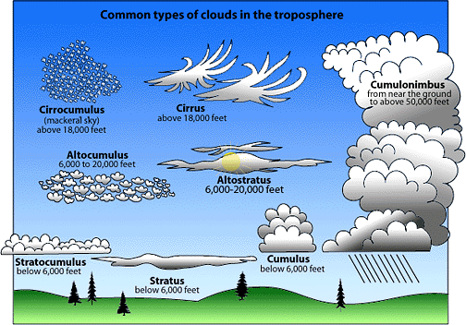

1. Cumulus Clouds:
- Heaped" or "lumpy" clouds result when strong vertical (upward) motions exist in the atmosphere.
- This shows us that the air mass is being forced to rise very rapidly.
- Cumulus clouds are a clue that the atmosphere is unstable and are usually associated with stormy or severe weather.

2. Stratus Clouds:
- Wide spread out, smooth, layered clouds.
- These clouds give a clue that the air motion is horizontal (across) rather than vertical (up and down).
- We see this when the air mass that the clouds are forming in are rising slowly.
- This type of cloud is a sign of a stable atmosphere.
Cloud cover Maintains balance on earth:
- Clouds play two main roles
- The first is that they simply act as a blanket.
  - On cloudy nights the cloud cover traps the heat from the earth keeping the air warm.
  - When the night sky is clear the earth's heat escapes and the air cools quickly.
- The second role of clouds is to keep the earth cool during the day.
  - The formation of white cloud cover, reflects the sun's energy away.
When is there a greater risk of frost, on a cloudy night or a clear night?
- Clear night because temperature drops quickly therefore reaching the dew point and if it is cold enough, frost will form

Deserts regions are so dry that clouds do not form during the day or the night. What do you think the temperature conditions would be like?
- In the day due to lack of cloud cover, the desert would receive high temperatures caused by direct sunlight
- In the night, the temperatures will likely get very cold due to lack of cloud cover which results in most of the heat escaping into space

Homework: Page 229: # 1

