Global Weather 2
Outcome: (212-1)

Content: Page 214-215
- As you recall from a previous lesson, humidity is ______________
_______________________________________________.
  - The humidity in the air can be measured using a ____________________________
- Relative humidity is a measure of the ______________________
__________________________________________________________________________________________________________.
  - Relative humidity can be measured using a ____________.
Humidity – Water in the Air
- The humidity of an air mass depends a great deal on the ______________________.
- 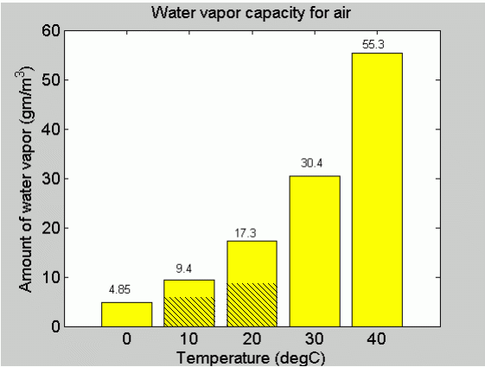
- Figure 1 Page 214 shows us the maximum amount of water that air can hold at _______________________. From this figure we can see that __________________________________________
______________________________.
- The reason for this is because warm air molecules are more spread out which ____________________________________________
____________________________________________.

What does humidity have to do with our level of comfort?
- Your body ____________________________________________ at all times. In hot weather makes you sweat. The sweat then evaporates. __________________________________________
______________________________.
- If humidity levels are high (high moisture content) _____________
________________________________________.
  - This is because __________________________________
________________________.
  - The sweat remains on your body leaving ______________
_____________________________.
  - Sweat evaporation stops completely when the relative humidity reaches about _____________________.
- At low humidity levels the air is ___________________________.
  - The dry air can soak up more water vapour ____________
____________________________________.
  - This makes you feel _______________________________.

What happens when the air is cooled?
- Warm air has more room between its air ____________________
______________________________________________.
- As the air cools, the air molecules begin to contract and there is ____________________________________________________.
- If the air is cooled enough eventually a temperature is reached when the ____________________________________________.
- The temperature at which condensation occurs is called the __________________.
- If the air has a high humidity ____________________________
______________________________________.
  - This makes sense since __________________________
____________________. A tiny amount of cooling will be enough to squeeze out some water.
- Questions: Which mass of air will reach its dew point first? air at 20ºC with humidity of 70% or air at 20ºC with humidity of 50% ?
  - _______________________________________________
________________________________________________
Common examples of Dew Point:
- Dew point can be observed when you see ___________________
____________________________________________________.
  - The steam from the hot shower ______________________
____________________________________________.
  - When this warm moist air hits a cooler mirror the _________
________________________________________________
- On calm clear nights we see the same effect when the land cools ____________________________________________________.
  - If the air cools below its dew point, ___________________
___________________________________________.
  - During the winter, the same effect can occur but this time is the ground cools below freezing and we see the formation of frost.
- During the summer, basements tend to get damp because of the high humidity. What could we do to dry up the air in the basement?
  - Use a de-humidifier which ___________________________
  - ________________________________________________
  - Turn the heat up __________________________________

What does humidity have to do with the weather?
- When the air reaches its maximum amount of water that it can hold (saturation point) _______________________________________
_____________________________________________________.
- In other words, the higher the humidity, _____________________
_____________________________________________________.
Homework: Page 215: #’s 1, 2, 4
SRL: 4.7, Page 335 - 336

