Global Weather 2
Outcome: (212-1)

Content: Page 214-215
- As you recall from a previous lesson, humidity is a measure of the amount of water vapour in the air.
  - The humidity in the air can be measured using a hygrometer.
- Relative humidity is a measure of the amount of water vapour that is in the air compared to the maximum amount of water vapour that the air can hold.
  - Relative humidity can be measured using a psychrometer.
Humidity – Water in the Air
- The humidity of an air mass depends a great deal on the temperature of the air.
- 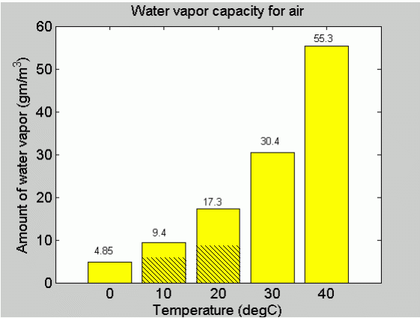
- Figure 1 Page 214 shows us the maximum amount of water that air can hold at different temperatures. From this figure we can see that warm air can hold much more water vapour than cold air.
- The reason for this is because warm air molecules are more spread out which makes more space for water vapour to fit in between.

What does humidity have to do with our level of comfort?
- Your body tries to maintain a constant temperature of 37°C at all times. In hot weather makes you sweat. The sweat then evaporates. When water evaporates it has a cooling effect.
- If humidity levels are high (high moisture content) sweat does not evaporate as easily.
  - This is because there is already a great deal of water vapour in the air.
  - The sweat remains on your body leaving you feeling hot and sticky.
  - Sweat evaporation stops completely when the relative humidity reaches about 90 percent.
- At low humidity levels the air is not holding much water.
  - The dry air can soak up more water vapour and your sweat evaporates more quickly.
  - This makes you feel dry and comfortable.

What happens when the air is cooled?
- Warm air has more room between its air molecules and holds more water vapour than cold air.
- As the air cools, the air molecules begin to contract and there is no longer enough room for all the water vapour.
- If the air is cooled enough eventually a temperature is reached when the water vapour is forced out and the water condenses.
- The temperature at which condensation occurs is called the Dew point.
- If the air has a high humidity it won't take much cooling to reach the dew point.
  - This makes sense since the air is already pretty much full. A tiny amount of cooling will be enough to squeeze out some water.
- Questions: Which mass of air will reach its dew point first? air at 20ºC with humidity of 70% or air at 20ºC with humidity of 50% ?
  - 70% because they are at the same temperature so the one with the higher humidity makes all the difference
Common examples of Dew Point:
- Dew point can be observed when you see mirrors steam up when you are in the shower.
  - The steam from the hot shower fills the air in the room with water vapour.
  - When this warm moist air hits a cooler mirror the water vapour condenses on the mirror.
- On calm clear nights we see the same effect when the land cools quickly causing the air touching the land to cool quickly too.
  - If the air cools below its dew point, dew will form on the ground.
  - During the winter, the same effect can occur but this time is the ground cools below freezing and we see the formation of frost.
- During the summer, basements tend to get damp because of the high humidity. What could we do to dry up the air in the basement?
  - Use a de-humidifier which cools the air to its dew point and takes in the moisture that is released
  - Turn the heat up which we know holds more moisture

What does humidity have to do with the weather?
- When the air reaches its maximum amount of water that it can hold (saturation point) the water vapour will start to condense forming clouds and precipitation.
- In other words, the higher the humidity, the greater the chance of rain or snow.
Homework: Page 215: #’s 1, 2, 4
SRL: 4.7, Page 335 - 336

