 | Rank | Name | Net Worth | Change | Age | Source | Country of Citizenship
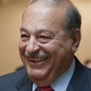 | #1 | Carlos Slim Helu & family | $82.7 B | $67.5 M | -0.1% | 74 | telecom | Mexico
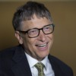 | #2 | Bill Gates | $81.5 B | $392 K | 58 | Microsoft | United States
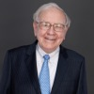 | #3 | Warren Buffett | $68.6 B | $1 K | 84 | Berkshire Hathaway | United States
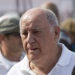 | #4 | Amancio Ortega | $60.9 B | $0 | 78 | retail | Spain
 | #5 | Larry Ellison | $49.1 B | $2.2 M | 70 | Oracle | United States
 | #6 | Charles Koch | $43.1 B | $0 | 78 | diversified | United States
 | #6 | David Koch | $43.1 B | $0 | 74 | diversified | United States
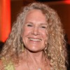 | #8 | Christy Walton & family | $38.5 B | $0 | 59 | Wal-Mart | United States
 | #9 | Jim Walton | $36.9 B | $0 | 66 | Wal-Mart | United States
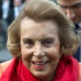 | #10 | Liliane Bettencourt & family | $35.7 B | $258.8 M | -0.7% | 91 | L'Oreal | France
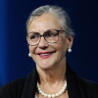 | #11 | Alice Walton | $35.4 B | $0 | 64 | Wal-Mart | United States
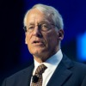 | #12 | S. Robson Walton | $35.4 B | $1 K | 70 | Wal-Mart | United States
 | #13 | Mark Zuckerberg | $34.6 B | $0 | 30 | Facebook | United States
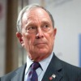 | #14 | Michael Bloomberg | $34.5 B | $0 | 72 | Bloomberg LP | United States
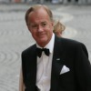 | #15 | Stefan Persson | $33.4 B | $225.1 M | -0.7% | 66 | H&M | Sweden
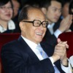 | #16 | Li Ka-shing | $33.1 B | $79.4 M | 0.2% | 86 | diversified | Hong Kong
 | #17 | Larry Page | $32.2 B | $0 | 41 | Google | United States
 | #18 | Sergey Brin | $31.7 B | $1 K | 41 | Google | United States
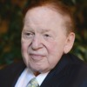 | #19 | Sheldon Adelson | $31.5 B | $0 | 81 | casinos | United States
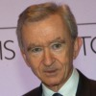 | #20 | Bernard Arnault & family | $31 B | $211.1 M | 0.7% | 65 | LVMH | France
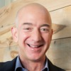 | #21 | Jeff Bezos | $30.3 B | $0 | 50 | Amazon.com | United States
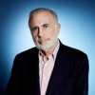 | #22 | Carl Icahn | $25.9 B | $0 | 78 | investments | United States
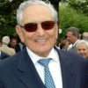 | #23 | Michele Ferrero & family | $25.7 B | $0 | 89 | chocolates | Italy
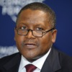 | #24 | Aliko Dangote | $24.3 B | $1 K | 57 | cement, sugar, flour | Nigeria
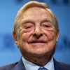 | #25 | George Soros | $24 B | $0 | 84 | hedge funds | United States
 | #26 | David Thomson & family | $23.8 B | $0 | 57 | media | Canada
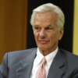 | #27 | Jorge Paulo Lemann | $22.8 B | $38 M | 0.2% | 75 | beer | Brazil
 | #28 | Lee Shau Kee | $22.7 B | $77.4 M | -0.3% | 86 | diversified | Hong Kong
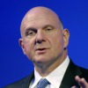 | #29 | Steve Ballmer | $22.6 B | $0 | 58 | Microsoft | United States
 | #30 | Forrest Mars Jr | $22.4 B | $0 | 83 | candy | United States
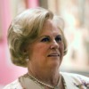 | #30 | Jacqueline Mars | $22.4 B | $0 | 74 | candy | United States
 | #32 | John Mars | $22.4 B | $0 | 78 | candy | United States
 | #33 | Prince Alwaleed Bin Talal Alsaud | $21.9 B | $7.2 M | 59 | investments | Saudi Arabia
 | #34 | Mukesh Ambani | $21.6 B | $764.4 M | -3.5% | 57 | petrochemicals, oil & gas | India
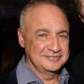 | #35 | Len Blavatnik | $21.5 B | $17.4 M | 0.1% | 57 | diversified | United States
 | #36 | Jack Ma | $20.2 B | $1 K | 50 | e-commerce | China
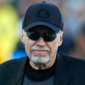 | #37 | Phil Knight | $19.7 B | $0 | 76 | Nike | United States
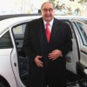 | #38 | Alisher Usmanov | $19 B | $89.3 M | 0.5% | 61 | steel & mining, telecom, investments | Russia
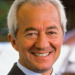 | #39 | Leonardo Del Vecchio | $18.7 B | $177.2 M | -0.9% | 79 | eyeglasses | Italy
 | #40 | Dieter Schwarz | $18.6 B | $0 | 75 | retail | Germany
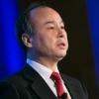 | #41 | Masayoshi Son | $17.7 B | $87.2 M | 0.5% | 57 | internet, telecom | Japan
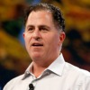 | #42 | Michael Dell | $17.6 B | $0 | 49 | Dell | United States
 | #43 | Theo Albrecht Jr & family | $17.4 B | $0 | 63 | Aldi, Trader Joe's | Germany
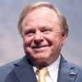 | #44 | Harold Hamm | $17.4 B | $0 | 68 | oil & gas | United States
 | #45 | Dilip Shanghvi | $17.3 B | $140.8 M | -0.8% | 58 | pharmaceuticals | India
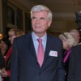 | #46 | Michael Otto & family | $17.2 B | $2.7 M | 71 | retail, real estate | Germany
 | #47 | Paul Allen | $17.1 B | $1 K | 61 | Microsoft, investments | United States
 | #48 | Mikhail Fridman | $17.1 B | $13.5 M | 0.1% | 50 | oil, banking, telecom | Russia
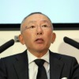 | #49 | Tadashi Yanai & family | $16.9 B | $205.3 M | 1.2% | 65 | retail | Japan
 | #50 | Charles Ergen | $16.7 B | $1 K | 61 | Dish Network | United States

