Local Weather 2
Outcome: (114-6), (212-8)
Content: Page 202-205

Build a Weather Station:
- One of the best ways to learn about the weather is _________________________________________________________________________________________.
- In order to build a weather station, some of the ___________________________________________________________________________________ must be considered.
- Some of the factors that must be measured or at least be able to detect a change include;
  - _________________________________,
  - _________________________________,
  - __________________________________,
  - __________________________________,
  - __________________________________.
Measuring devices commonly used in a weather station:
- ___________________________________
- ____________________________________
- ___________________________________
- ____________________________________
- ___________________________________
- ___________________________________
- __________________________________.

1. Thermometer:
  - A thermometer is a device used to _________________________________________________________________________________________
  - 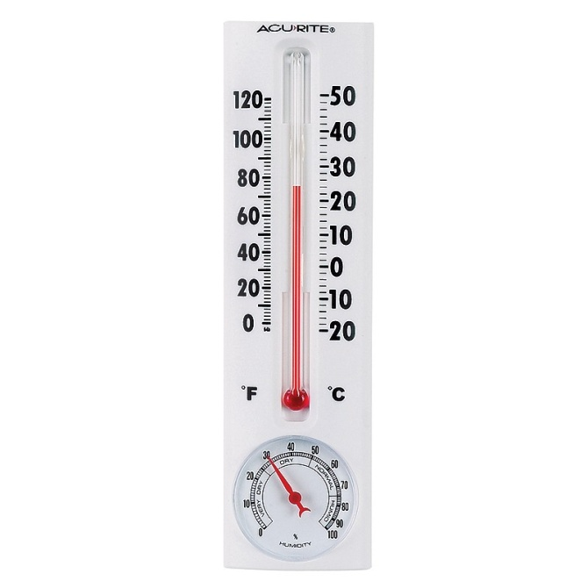
  - How does a thermometer work?
  - The mercury (or alcohol) in the bulb is mostly located in ______________________________________________________________________________
  - When the temperature rises, ____________________________________________________________________________, which is marked (calibrated) to show the actual temperature outside
  - Does it matter if the thermometer is placed in the sun or shade?
  - The thermometer will obviously show a __________________________________________________________________________, therefore this must be considered when placing the thermometer
  - Temperature is considered an important weather factor because it will determine __________________________________________________________________________________________
  - Temperature is also related to our level of ___________________________.
  - If it is cold outside, _________________________________________________________________________________________.
  - On a hot summer day we would dress quite __________________________________

2. Hygrometer:
- Device used to measure the __________________________________________
- 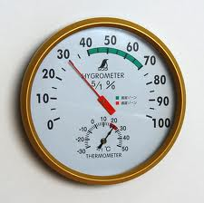
- Humidity is a measure of the how much ____________________________________________.
- Have you ever seen your breath on a cold day?
  - ____________________________________, just like the water in clouds, rain, or moisture in the air.
- What does humidity have to do with the weather?
  - Warm air can _______________________________________________________________________________
  - The more water that is in the air the ________________________________________________________________________________
  - So warm, wet air is usually associated with _______________________________________.
  - The hygrometer can detect a change in humidity and thus ________________________________________________________________________________
- Here are the observations and their meanings.
  - When a Warm Front moves in:
    - When a warm front (mass of warm air) approaches, the ____________________________________________________________________________________________________________
    - The humidity stays high while the warm air is around, and then ____________________________________________________________________________________________________________
  - When a Cold Front moves in:
    - When a cold front (mass of cold air) approaches, ___________________________________________________________________________________________________________.
    - When the cold front arrives ___________________________________________________________________________________________________________
    - As the cold fronts moves away the ____________________________________
  - So by measuring the change in humidity _______________________________________________________________________________
- This type of hygrometer just shows that ____________________________________________
- In order to get an actual number value on humidity levels you will have to build a __________________.

3. Psychrometer:
- Device that measures the amount ___________________________________________
- 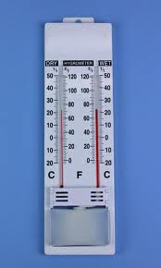
- Relative humidity is a measure of the _____________________________________________ compared to the _________________________________________________________________________________________
  - The air can hold a maximum amount of water.
  - If we can measure how much water is actually in the air we can then _______________________________________________________________________________.
- A psychrometer is made up of ____________________________________________.
- One thermometer is ordinary (dry bulb) and the other has a cloth wick (skate lace) over its bulb.
- The one with the wick over it is called a __________________________________________
- When you are ready to take a reading, dip the wick (skate lace) in water and then fan air over the thermometers.
- When the air is blowing over the wick the water evaporates and has a _________________________________________________________________________________________.
- After a few seconds you take a reading of the temperatures of both thermometers.
- Understanding the Reading:
  - If the surrounding air is dry, _______________________________________
  - The more water that evaporates the ________________________________________
  - There will be ______________________ between the dry bulb and the wet bulb.
  - If the surrounding air is very damp then only a small amount of water will evaporate and the ________________________________________________________________________________
  - The smaller the difference the ________________________________________
  - If the surrounding air is holding as much moisture as possible (if the relative humidity is 100%) there _______________________________________________________________________.
- As we know the higher the humidity (the more water that there is in the air) the __________________________________________________________________________________________
- Meteorologists have made up charts of these differences between the wet and dry bulbs at each temperature. By using the chart you can find __________________________. (Table 1 Page 203)
- Example: A psychrometer reading gives the dry bulb reading of 20ºC and a wet bulb reading of 18ºC. What is the relative humidity?

4. Aneroid barometer:
- Device used to measure surrounding __________________________________________
- 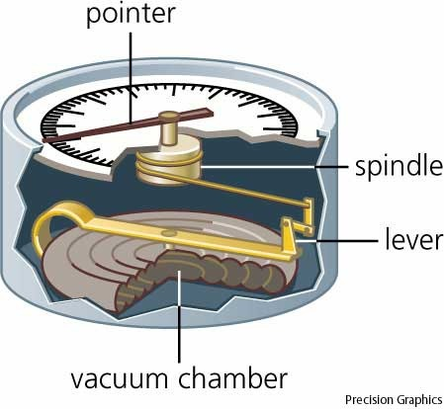
- Air pressure is the force that _____________________________________________
- Cold air is denser (thicker and heavier) than warm air.
- Recall that cold matter __________________ (shrinks) therefore as air cools, it begins to get ________________________________________.
- The colder the air, the more we can _________________________________________________________________________________________
- As a result ________________________________________________________________________________________
- The rising of the air pressure tells that a ______________________________________is moving in.
  - The high-pressure system is made up of cool, dry air. So a high barometric pressure is usually associated with cool, clear, dry air – ____________________________________.
- If the air pressure begins to drop that means a __________________________________ is moving in.
  - A low-pressure system is usually warmer, moist air - _______________________________

5. Wind vane:
- Tool that measures the _____________________________________________
- 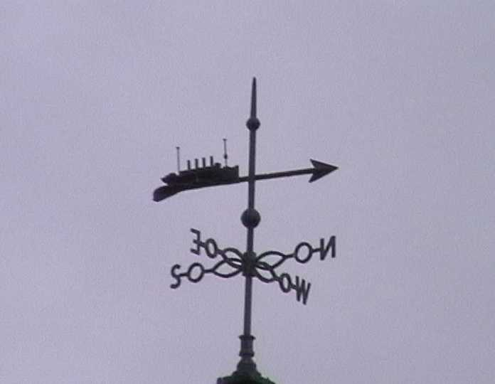
- A typical wind vane would have __________________________________________________________________________________________ and compass bearing.
- The part of the vane that turns into the wind is usually shaped like an ____________________.
- The ____________________________ so it will catch the smallest breeze.
- The breeze turns the arrow until it catches both sides of the wide end equally.
- The arrow ____________________________________________.
- The arrow tells you the __________________ that the wind is coming from.
- If the wind is blowing from the south, ____________________________________________
- If the wind is blowing from the north, ____________________________________________
- The weather associated with wind direction depends a great deal on your local geography.
  - For instance, on the east coast of the Island an easterly wind is generally off the water and is cool and wet, usually ________________________________________
  - Where as, on the west coast of the island a westerly wind would be blowing off the water.

6. Anemometer:
- Used to measure the ______________________________.
- 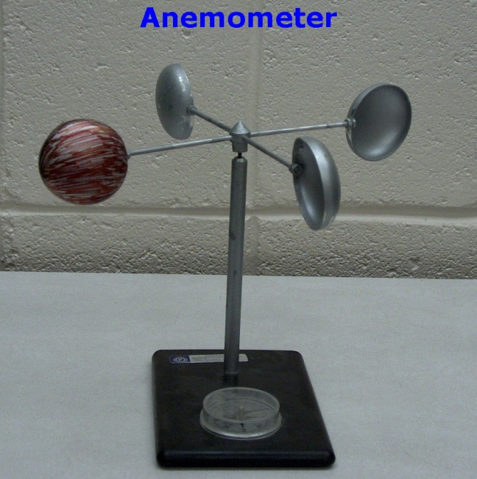

- The simplest of all anemometers is the ____________________________________________
- 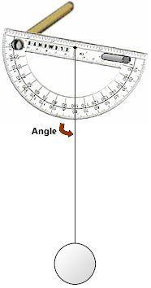
  - When the wind blows the ping-pong ball suspended on the end of a ________________________________________
  - The angle of the string is recorded and then the ________________________________________
- The pressure anemometer is another simple device used to measure wind speed.
  - Has a small plastic bead in a ______________.
  - When the wind blows over the top of the tube it creates a ____________________________________________________________________________.
  - The higher the bead rises, the _______________________________________
- A rotation anemometer
  - Consist of a _______________________________________________________________________________. As it spins, you can count the rotations (number of spins) that it makes in ten seconds.
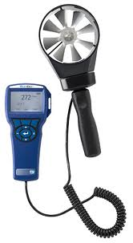
  - This homemade anemometer cannot not tell the wind speed in kilometres per hour; but it can give you an idea of how fast the wind is blowing.
- More precise Weather forecasters' anemometers have the propeller connected to a small generator and computer that can ________________________________________________________________________________________ into kilometres per hour. (km/h).

7. Rain gauge:
- Tool, which collects and measures the _________________________________________
- 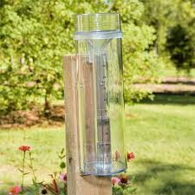
- It is simply a bottle or can with a millimetre scale.
- As it rains, the _________________________________________________________________________________________ in the bottle (in mm).
- Snow is measured the same way but is measured in cm.

Homework: Page 205: # 2, 3, 4

