Local Weather 2
Outcome: (114-6), (212-8)
Content: Page 202-205

Build a Weather Station:
- One of the best ways to learn about the weather is to build and use your own weather station.
- In order to build a weather station, some of the important factors that affect the weather must be considered.
- Some of the factors that must be measured or at least be able to detect a change include;
  - Air temperature,
  - Humidity,
  - Wind direction,
  - Wind speed,
  - And air pressure.
Measuring devices commonly used in a weather station:
- Thermometer
- Hygrometer
- Psychrometer
- Aneroid barometer
- Wind vane
- Anemometer
- Rain gauge.

1. Thermometer:
  - A thermometer is a device used to measure the outside air temperature.
  - 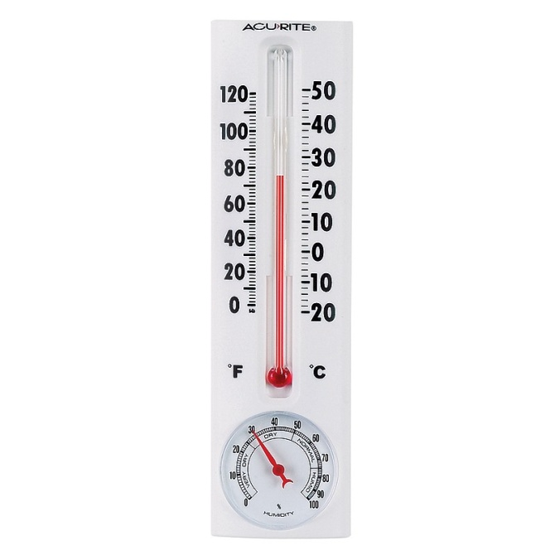
  - How does a thermometer work?
  - The mercury (or alcohol) in the bulb is mostly located in the bulb of the thermometer
  - When the temperature rises, the liquid expands and rises up the tube, which is marked (calibrated) to show the actual temperature outside
  - Does it matter if the thermometer is placed in the sun or shade?
  - The thermometer will obviously show a colder temperature in shade than in the sun, therefore this must be considered when placing the thermometer
  - Temperature is considered an important weather factor because it will determine the type of precipitation (rain /snow) we may get.
  - Temperature is also related to our level of comfort.
  - If it is cold outside, we may wear a heavy coat to keep us warm.
  - On a hot summer day we would dress quite differently.

2. Hygrometer:
- Device used to measure the humidity of the air.
- 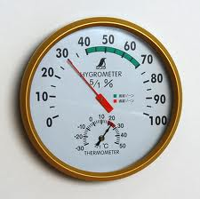
- Humidity is a measure of the how much moisture (water vapour) is in the air.
- Have you ever seen your breath on a cold day?
  - That's moisture in your breath, just like the water in clouds, rain, or moisture in the air.
- What does humidity have to do with the weather?
  - Warm air can hold more water than cold air.
  - The more water that is in the air the greater the chance for precipitation (rain or snow).
  - So warm, wet air is usually associated with wet, stormy weather.
  - The hygrometer can detect a change in humidity and thus predict a change in the weather.
- Here are the observations and their meanings.
  - When a Warm Front moves in:
    - When a warm front (mass of warm air) approaches, the humidity of the surrounding air begins to rise as the warm front moves in.
    - The humidity stays high while the warm air is around, and then the humidity slowly drops as the warm air moves away.
  - When a Cold Front moves in:
    - When a cold front (mass of cold air) approaches, the humidity doesn’t change much as the cold air moves in.
    - When the cold front arrives the humidity will rise quickly and stay high while it is there.
    - As the cold fronts moves away the humidity will drop quickly.
  - So by measuring the change in humidity we can tell if a warm front or a cold front is approaching.
- This type of hygrometer just shows that humidity is changing.
- In order to get an actual number value on humidity levels you will have to build a psychrometer.

3. Psychrometer:
- Device that measures the amount of relative humidity in the air.
- 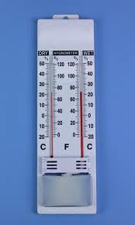
- Relative humidity is a measure of the amount of water vapour that is in the air compared to the maximum amount of water vapour that the air can hold.
  - The air can hold a maximum amount of water.
  - If we can measure how much water is actually in the air we can then figure out its percentage or relative humidity.
- A psychrometer is made up of two thermometers mounted together.
- One thermometer is ordinary (dry bulb) and the other has a cloth wick (skate lace) over its bulb.
- The one with the wick over it is called a wet-bulb thermometer.
- When you are ready to take a reading, dip the wick (skate lace) in water and then fan air over the thermometers.
- When the air is blowing over the wick the water evaporates and has a cooling effect on the wet-bulb thermometer.
- After a few seconds you take a reading of the temperatures of both thermometers.
- Understanding the Reading:
  - If the surrounding air is dry, more water evaporates from the wick.
  - The more water that evaporates the cooler the reading will be.
  - There will be a large difference between the dry bulb and the wet bulb.
  - If the surrounding air is very damp then only a small amount of water will evaporate and the two bulbs will be about the same.
  - The smaller the difference the greater the humidity.
  - If the surrounding air is holding as much moisture as possible (if the relative humidity is 100%) there is no difference between the two temperatures.
- As we know the higher the humidity (the more water that there is in the air) the greater the chance of rain or snow.
- Meteorologists have made up charts of these differences between the wet and dry bulbs at each temperature. By using the chart you can find relative humidity. (Table 1 Page 203)
- Example: A psychrometer reading gives the dry bulb reading of 20ºC and a wet bulb reading of 18ºC. What is the relative humidity?

4. Aneroid barometer:
- Device used to measure surrounding air pressure.
- 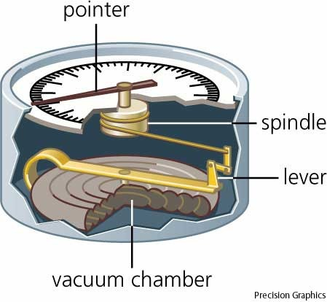
- Air pressure is the force that air pushes down on the earth.
- Cold air is denser (thicker and heavier) than warm air.
- Recall that cold matter contracts (shrinks) therefore as air cools, it begins to get squeezed together.
- The colder the air, the more we can squeeze into the same size air mass.
- As a result cold air is heavier than warm air.
- The rising of the air pressure tells that a high-pressure system is moving in.
  - The high-pressure system is made up of cool, dry air. So a high barometric pressure is usually associated with cool, clear, dry air – fine weather.
- If the air pressure begins to drop that means a low-pressure system is moving in.
  - A low-pressure system is usually warmer, moist air - poor weather on the way.

5. Wind vane:
- Tool that measures the direction of the wind.
- 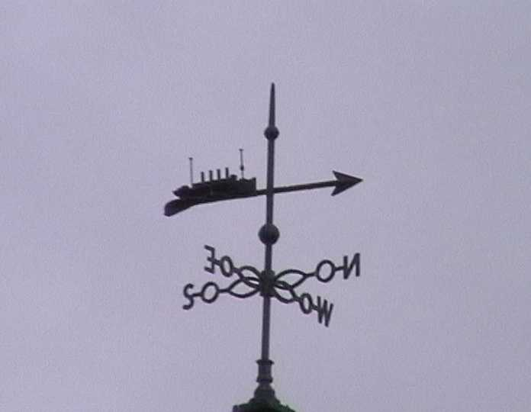
- A typical wind vane would have a pointer that can spin with one end larger than the other and compass bearing.
- The part of the vane that turns into the wind is usually shaped like an arrow.
- The other end is wide so it will catch the smallest breeze.
- The breeze turns the arrow until it catches both sides of the wide end equally.
- The arrow always points into the wind.
- The arrow tells you the direction that the wind is coming from.
- If the wind is blowing from the south, the wind is usually warm.
- If the wind is blowing from the north, the wind is usually cooler.
- The weather associated with wind direction depends a great deal on your local geography.
  - For instance, on the east coast of the Island an easterly wind is generally off the water and is cool and wet, usually bringing fog and rain.
  - Where as, on the west coast of the island a westerly wind would be blowing off the water.

6. Anemometer:
- Used to measure the speed of the wind.
- 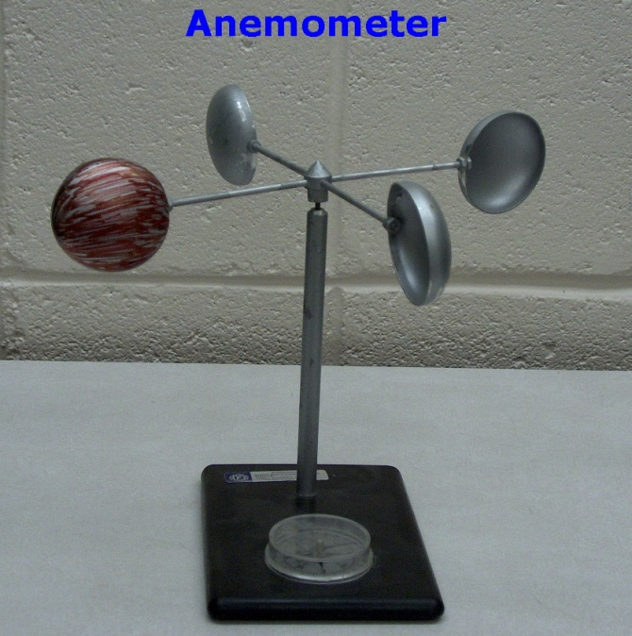

- The simplest of all anemometers is the ping-pong ball anemometer.
- 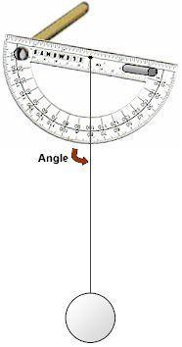
  - When the wind blows the ping-pong ball suspended on the end of a string is moved.
  - The angle of the string is recorded and then the speed of the wind can be estimated.
- The pressure anemometer is another simple device used to measure wind speed.
  - Has a small plastic bead in a glass tube.
  - When the wind blows over the top of the tube it creates a vacuum that sucks up the small plastic bead.
  - The higher the bead rises, the higher the wind speed.
- A rotation anemometer
  - Consist of a windmill, or a propeller, or three or more cone shaped cups. As it spins, you can count the rotations (number of spins) that it makes in ten seconds.
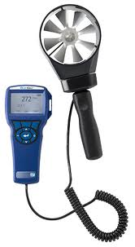
  - This homemade anemometer cannot not tell the wind speed in kilometres per hour; but it can give you an idea of how fast the wind is blowing.
- More precise Weather forecasters' anemometers have the propeller connected to a small generator and computer that can accurately count and calculate the revolutions per minute into kilometres per hour. (km/h).

7. Rain gauge:
- Tool, which collects and measures the amount of rainfall.
- 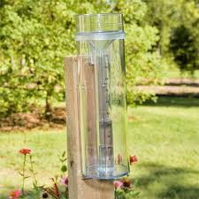
- It is simply a bottle or can with a millimetre scale.
- As it rains, the bottle fills and then you go out and measure the height of the water in the bottle (in mm).
- Snow is measured the same way but is measured in cm.

Homework: Page 205: # 2, 3, 4

